WEEK 1 TASK REPORT
Python for Machine Learning & Data Preprocessing

Name | P.KAVYA
Roll Number | ES24CS77
Department | Computer Science and Engineering
Week | Week 1
Task | Python, NumPy, Pandas and Data Preprocessing

1. Objective
The objective of this task is to understand Python fundamentals used in machine learning, work with NumPy and Pandas, and apply common data preprocessing techniques. A small student dataset is used to demonstrate data loading, cleaning, missing-value handling, feature selection, categorical encoding, normalization, and exploratory data analysis (EDA).

2. Tools and Libraries Used
• Python 3
• Pandas – data loading, cleaning and analysis
• NumPy – numerical operations
• Matplotlib – data visualization

3. Python Fundamentals
The basic Python concepts required for this task include variables, data types, conditional statements, loops, lists, dictionaries, functions, and basic input/output. Python is widely used in machine learning because it has simple syntax and provides libraries such as NumPy, Pandas and scikit-learn.

4. NumPy
NumPy provides array-based numerical operations. Arrays can be used for mathematical calculations, indexing, slicing and statistical operations.
import numpy as np
marks = np.array([85, 92, 76, 68])
print("Average:", marks.mean())
print("Maximum:", marks.max())
Output:
Average: 80.25
Maximum: 92

5. Pandas
Pandas provides DataFrame and Series structures for handling tabular data. It can read CSV files, inspect data, filter rows and columns, handle missing values and calculate statistics.
import pandas as pd
df = pd.read_csv("student_dataset_raw.csv")
print(df.head())
print(df.info())
print(df.describe())

6. Dataset Description
The sample dataset contains 12 student records. The columns are Name, Age, Gender, Marks, Attendance, Study_Hours and Placement_Ready. Missing values were intentionally included in Marks and Attendance to demonstrate data cleaning.
Name | Age | Gender | Marks | Attendance | Study_Hours | Placement_Ready
Arun | 20 | Male | 85.00 | 90.00 | 3.50 | Yes
Priya | 19 | Female | 92.00 | 95.00 | 4.50 | Yes
Ravi | 21 | Male |  | 80.00 | 2.00 | No
Meena | 20 | Female | 76.00 |  | 3.00 | No
Karthik | 22 | Male | 68.00 | 72.00 | 2.50 | No
Divya | 19 | Female | 88.00 | 96.00 | 4.00 | Yes
Sanjay | 21 | Male | 74.00 | 85.00 | 2.50 | No
Anu | 20 | Female | 95.00 | 98.00 | 5.00 | Yes
Vijay | 23 | Male | 81.00 | 78.00 | 3.00 | Yes
Nisha | 19 | Female |  | 88.00 | 3.50 | Yes
Rahul | 22 | Male | 79.00 |  | 2.00 | No
Keerthi | 20 | Female | 91.00 | 94.00 | 4.50 | Yes

7. Step 1 – Load the Dataset
import pandas as pd
df = pd.read_csv("student_dataset_raw.csv")
print(df.shape)
print(df.head())
Output: The dataset contains 12 rows and 7 columns.

8. Step 2 – Check Missing Values
print(df.isnull().sum())
Output:
Name 0
Age 0
Gender 0
Marks 2
Attendance 2
Study_Hours 0
Placement_Ready 0
Marks has 2 missing values and Attendance has 2 missing values. The other columns do not contain missing values.

9. Step 3 – Handle Missing Values
The missing numerical values are replaced using the median of their respective columns. The median is useful because it is less affected by extreme values than the mean.
df["Marks"] = df["Marks"].fillna(df["Marks"].median())
df["Attendance"] = df["Attendance"].fillna(df["Attendance"].median())
Output: Marks median used = 83.0; Attendance median used = 89.0.

10. Step 4 – Feature Selection
For a simple analysis, the numerical features Age, Marks, Attendance and Study_Hours are selected. Name is not required for numerical modeling.
features = ["Age", "Marks", "Attendance", "Study_Hours"]
X = df[features]
print(X.head())
Age | Marks | Attendance | Study_Hours
20.00 | 85.00 | 90.00 | 3.50
19.00 | 92.00 | 95.00 | 4.50
21.00 | 83.00 | 80.00 | 2.00
20.00 | 76.00 | 89.00 | 3.00
22.00 | 68.00 | 72.00 | 2.50
19.00 | 88.00 | 96.00 | 4.00
21.00 | 74.00 | 85.00 | 2.50
20.00 | 95.00 | 98.00 | 5.00
23.00 | 81.00 | 78.00 | 3.00
19.00 | 83.00 | 88.00 | 3.50
22.00 | 79.00 | 89.00 | 2.00
20.00 | 91.00 | 94.00 | 4.50

11. Step 5 – Encode Categorical Variables
Machine learning algorithms generally work with numerical values. Therefore, Gender and Placement_Ready are converted into binary numerical values.
df["Gender_Encoded"] = df["Gender"].map({"Female": 0, "Male": 1})
df["Placement_Ready_Encoded"] = df["Placement_Ready"].map({"No": 0, "Yes": 1})
Encoding used:
• Gender: Female = 0, Male = 1
• Placement_Ready: No = 0, Yes = 1

12. Step 6 – Normalization
Min-Max normalization converts numerical values to a common range from 0 to 1. The formula is: normalized value = (x − minimum) / (maximum − minimum).
X_normalized = (X - X.min()) / (X.max() - X.min())
print(X_normalized.head())
Age_Normalized | Marks_Normalized | Attendance_Normalized | Study_Hours_Normalized
0.25 | 0.63 | 0.69 | 0.50
0.00 | 0.89 | 0.88 | 0.83
0.50 | 0.56 | 0.31 | 0.00
0.25 | 0.30 | 0.65 | 0.33
0.75 | 0.00 | 0.00 | 0.17
0.00 | 0.74 | 0.92 | 0.67
0.50 | 0.22 | 0.50 | 0.17
0.25 | 1.00 | 1.00 | 1.00
1.00 | 0.48 | 0.23 | 0.33
0.00 | 0.56 | 0.62 | 0.50
0.75 | 0.41 | 0.65 | 0.00
0.25 | 0.85 | 0.85 | 0.83

13. Step 7 – Exploratory Data Analysis (EDA)
Basic descriptive statistics are calculated to understand the dataset.
Statistic | Age | Marks | Attendance | Study_Hours
count | 12.00 | 12.00 | 12.00 | 12.00
mean | 20.50 | 82.92 | 87.83 | 3.33
std | 1.31 | 7.94 | 7.88 | 1.01
min | 19.00 | 68.00 | 72.00 | 2.00
25% | 19.75 | 78.25 | 83.75 | 2.50
50% | 20.00 | 83.00 | 89.00 | 3.25
75% | 21.25 | 88.75 | 94.25 | 4.12
max | 23.00 | 95.00 | 98.00 | 5.00
Average Marks = 82.92
Average Attendance = 87.83%
Placement-ready students = 58.33%
Gender count:
Female: 6
Male: 6
Placement readiness count:
Yes: 7
No: 5

14. Data Visualization
The following charts provide a simple visual view of the student data.
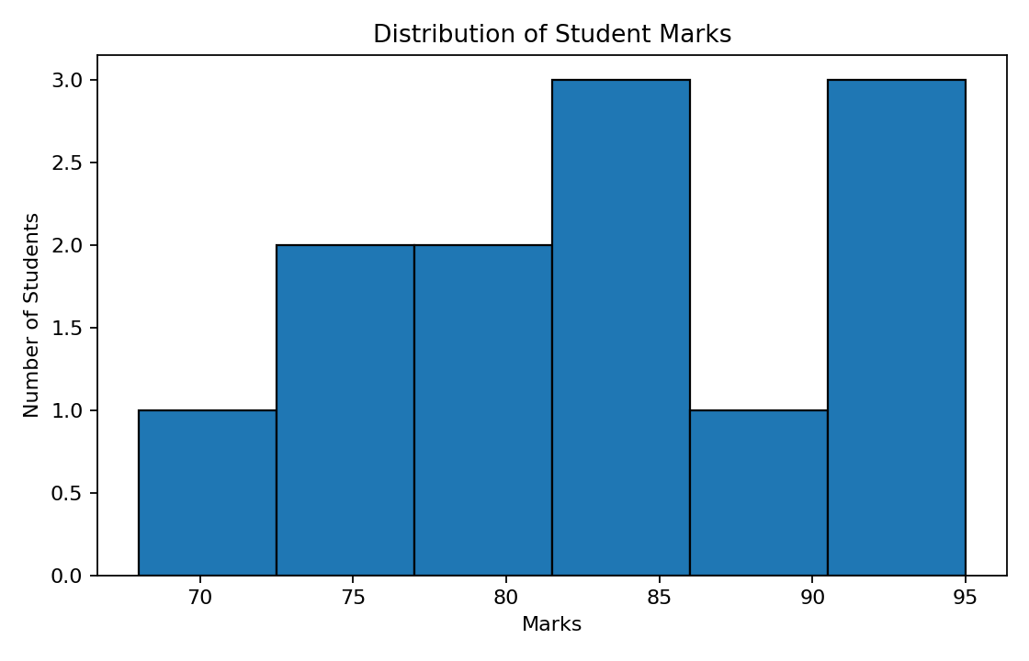
Figure 1: Distribution of Student Marks
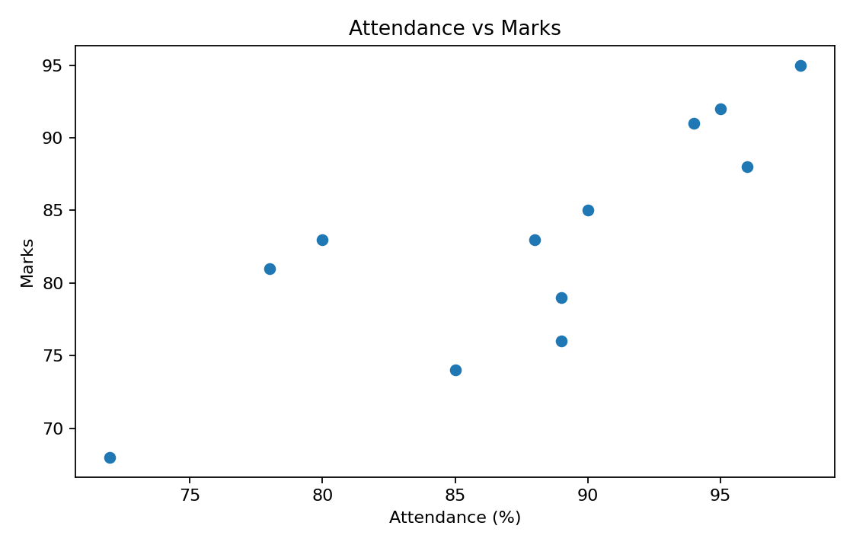
Figure 2: Attendance vs Marks

15. Complete Python Program
import pandas as pd
import numpy as np
import matplotlib.pyplot as plt
# Load data
df = pd.read_csv("student_dataset_raw.csv")
# Check data
print(df.head())
print(df.isnull().sum())
# Handle missing numerical values
df["Marks"] = df["Marks"].fillna(df["Marks"].median())
df["Attendance"] = df["Attendance"].fillna(df["Attendance"].median())
# Encode categorical variables
df["Gender_Encoded"] = df["Gender"].map({"Female": 0, "Male": 1})
df["Placement_Ready_Encoded"] = df["Placement_Ready"].map({"No": 0, "Yes": 1})
# Feature selection
features = ["Age", "Marks", "Attendance", "Study_Hours"]
X = df[features].copy()
# Min-Max normalization
X_normalized = (X - X.min()) / (X.max() - X.min())
print(X_normalized)
# EDA
print(df[features].describe())
print("Average Marks:", df["Marks"].mean())
print("Average Attendance:", df["Attendance"].mean())
# Visualization
plt.hist(df["Marks"], bins=6, edgecolor="black")
plt.title("Distribution of Student Marks")
plt.xlabel("Marks")
plt.ylabel("Number of Students")
plt.show()
plt.scatter(df["Attendance"], df["Marks"])
plt.title("Attendance vs Marks")
plt.xlabel("Attendance (%)")
plt.ylabel("Marks")
plt.show()
# Save processed data
processed = pd.concat([df, X_normalized.add_suffix("_Normalized")], axis=1)
processed.to_csv("student_dataset_processed.csv", index=False)

16. Result
The sample student dataset was successfully loaded and preprocessed using Python, Pandas and NumPy. Missing values were handled using median imputation, categorical variables were encoded, useful features were selected, numerical features were normalized to the 0–1 range, and basic EDA and visualizations were completed. The processed dataset was saved as a new CSV file.

17. Conclusion
This task provided practical experience with the main data preprocessing steps used before machine learning. The exercise shows how raw tabular data can be converted into a cleaner and more suitable form for further analysis or machine learning models.

